Bridge Seismic Vulnerability Modelling

Ken Dale
October 2004

Introduction
The failure of a bridge typically causes significant disruption to a transport network. As part of its work regarding catastrophic disaster simulation the Risk Research Group at Geoscience Australia (GA) will be assessing the vulnerability of highway bridges in the Perth region for a scenario earthquake. This represents the group’s first attempt at assessing the effect of an earthquake on a transport network. The methodology proposed in this paper is identical to that used in HAZUS-MH (2003). The majority of the technical detail in this paper is taken directly from Chapter 7 of the HAZUS-MH technical manual. The HAZUS methodology will enable the probability of a bridge being in a particular damage state to be calculated, and also provides information on time to restore the bridges functionality when in a particular damage state.

Bridge Damage Modelling
Earthquake damage to highway bridges can be estimated through the use of fragility curves. The curves allow the probability of a bridge being in a certain (defined) damage state to be calculated. Damage states can then be related to repair times for the bridge. The required inputs to estimate bridge damage states are:
- bridge location
- bridge classification
- spectral accelerations at 0.3 sec and 1.0 sec

Interdependence of components on overall network functionality is not addressed by this methodology. This would require a network system analysis performed by a highway system expert. The methodology does allow for bridge damage due to permanent ground displacements (PGD), although this type of damage will not be considered in the current study.

Bridge Fragility Curves
The fragility curves are represented by a lognormal cumulative distribution function (Eq 1).

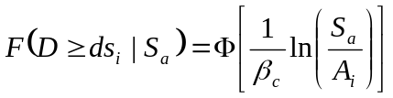 (1)

where Φ is the standard normal distribution function, S_{a} is the spectral acceleration (for T=1.0 sec.), A_{i} is the median spectral acceleration (in g’s) necessary to cause the ith damage state, and β_{c} is the normalised composite log-normal standard deviation which incorporates aspects of uncertainty and randomness for both capacity and demand. Based on the research of Mander and Basöz (1999), β_{c} is equal to 0.6.
Damage States
A total of five damage states are defined for highway bridges. These are none (ds1), slight/minor (ds2), moderate (ds3), extensive (ds4) and complete (ds5).

- ds2 is defined by minor cracking and spalling to the abutment, cracks in shear keys at abutments, minor spalling and cracks at hinges, minor spalling at the column (damage requires no more than cosmetic repair) or minor cracking to the deck
- ds3 is defined by any column experiencing moderate (shear cracks) cracking and spalling (column structurally still sound), moderate movement of the abutment (<50mm), extensive cracking and spalling of shear keys, any connection having cracked shear keys or bent bolts, keeper bar failure without unseating, rocker bearing failure or moderate settlement of the approach.
- ds4 is defined by any column degrading without collapse – shear failure - (column structurally unsafe), significant residual movement at connections, or major settlement approach, vertical offset of the abutment, differential settlement at connections, shear key failure at abutments.
- ds5 is defined by any column collapsing and connection losing all bearing support, which may lead to imminent deck collapse, tilting of substructure due to foundation failure.

Bridge Classification
Bridges are classified on the following structural characteristics:
- Seismic Design
- Number of spans: single vs. multiple
- Structure type: steel, concrete, others
- Pier type: multiple column bents, single column bents, pier walls
- Abutment type: monolithic vs. non-monolithic
- Bearing type: high rocker bearings, low steel bearings and neoprene rubber bearings
- Span continuity: continuous, discontinuous, and simply supported

The HAZUS methodology uses data from the US National Bridge Inventory (NBI), a database maintained by the Federal Highway Administration, to define bridges. The database has 116 fields used in describing a bridge. For (relative) simplicity the HAZUS methodology involves using fragility curves for 28 “standard bridges”. The curves can be modified through the use of bridge specific parameters from the NBI.

Table 1 and Table 2 summarise key NBI parameters used, and Table 3 presents the 28 classes used in HAZUS. More detailed definitions of the HAZUS bridge classifications are provided in Table 4.

Table 1: Bridge material Classes in NBI
Code | Description
1 | Concrete
2 | Concrete continuous
3 | Steel
4 | Steel continuous
5 | Prestressed concrete
6 | Prestressed concrete continuous
7 | Timber
8 | Masonry
9 | Aluminium, Wrought Iron, or Cast Iron
0 | Other

Table 2: Bridge Types in NBI
Code | Description
01 | Slab
02 | Stringer/Multi-beam or Girder
03 | Girder and Floor beam System
04 | Tee Beam
05 | Box Beam or Girders - Multiple
06 | Box Beam or Girders – single or Spread
07 | Frame
08 | Orthotropic
09 | Truss – Deck
10 | Truss – Thru
11 | Arch – Deck
12 | Arch – Thru
13 | Suspension
14 | Stayed Girder
15 | Movable – Lift
16 | Movable – Bascule
17 | Movable – Swing
18 | Tunnel
19 | Culvert
20 | Mixed Types (applicable only to approach spans)
21 | Segmental Box Girder
22 | Channel Beam
00 | Other

Table 3: HAZUS Bridge Classification Scheme
CLASS | NBI Class | State | Year Built | # Spans | Length of Max. Span (meter) | Length less than 20 m | K_{3D} | I_{shape} | Design | Description
HWB1 | All | Non-CA | < 1990 |  | > 150 | N/A | EQ1 | 0 | Conventional | Major Bridge - Length > 150m
HWB1 | All | CA | < 1975 |  | > 150 | N/A | EQ1 | 0 | Conventional | Major Bridge - Length > 150m
HWB2 | All | Non-CA | >= 1990 |  | > 150 | N/A | EQ1 | 0 | Seismic | Major Bridge - Length > 150m
HWB2 | All | CA | >= 1975 |  | > 150 | N/A | EQ1 | 0 | Seismic | Major Bridge - Length > 150m
HWB3 | All | Non-CA | < 1990 | 1 |  | N/A | EQ1 | 1 | Conventional | Single Span
HWB3 | All | CA | < 1975 | 1 |  | N/A | EQ1 | 1 | Conventional | Single Span
HWB4 | All | Non-CA | >= 1990 | 1 |  | N/A | EQ1 | 1 | Seismic | Single Span
HWB4 | All | CA | >= 1975 | 1 |  | N/A | EQ1 | 1 | Seismic | Single Span
HWB5 | 101-106 | Non-CA | < 1990 |  |  | N/A | EQ1 | 0 | Conventional | Multi-Col. Bent, Simple Support - Concrete
HWB6 | 101-106 | CA | < 1975 |  |  | N/A | EQ1 | 0 | Conventional | Multi-Col. Bent, Simple Support - Concrete
HWB7 | 101-106 | Non-CA | >= 1990 |  |  | N/A | EQ1 | 0 | Seismic | Multi-Col. Bent, Simple Support - Concrete
HWB7 | 101-106 | CA | >= 1975 |  |  | N/A | EQ1 | 0 | Seismic | Multi-Col. Bent, Simple Support - Concrete
HWB8 | 205-206 | CA | < 1975 |  |  | N/A | EQ2 | 0 | Conventional | Single Col., Box Girder - Continuous Concrete
HWB9 | 205-206 | CA | >= 1975 |  |  | N/A | EQ3 | 0 | Seismic | Single Col., Box Girder - Continuous Concrete
HWB10 | 201-206 | Non-CA | < 1990 |  |  | N/A | EQ2 | 1 | Conventional | Continuous Concrete
HWB10 | 201-206 | CA | < 1975 |  |  | N/A | EQ2 | 1 | Conventional | Continuous Concrete
HWB11 | 201-206 | Non-CA | >= 1990 |  |  | N/A | EQ3 | 1 | Seismic | Continuous Concrete
HWB11 | 201-206 | CA | >= 1975 |  |  | N/A | EQ3 | 1 | Seismic | Continuous Concrete
HWB12 | 301-306 | Non-CA | < 1990 |  |  | No | EQ4 | 0 | Conventional | Multi-Col. Bent, Simple Support - Steel
HWB13 | 301-306 | CA | < 1975 |  |  | No | EQ4 | 0 | Conventional | Multi-Col. Bent, Simple Support - Steel
HWB14 | 301-306 | Non-CA | >= 1990 |  |  | N/A | EQ1 | 0 | Seismic | Multi-Col. Bent, Simple Support - Steel
HWB14 | 301-306 | CA | >= 1975 |  |  | N/A | EQ1 | 0 | Seismic | Multi-Col. Bent, Simple Support - Steel
HWB15 | 402-410 | Non-CA | < 1990 |  |  | No | EQ5 | 1 | Conventional | Continuous Steel
HWB15 | 402-410 | CA | < 1975 |  |  | No | EQ5 | 1 | Conventional | Continuous Steel
HWB16 | 402-410 | Non-CA | >= 1990 |  |  | N/A | EQ3 | 1 | Seismic | Continuous Steel
HWB16 | 402-410 | CA | >= 1975 |  |  | N/A | EQ3 | 1 | Seismic | Continuous Steel
HWB17 | 501-506 | Non-CA | < 1990 |  |  | N/A | EQ1 | 0 | Conventional | Multi-Col. Bent, Simple Support - Prestressed Concrete
HWB18 | 501-506 | CA | < 1975 |  |  | N/A | EQ1 | 0 | Conventional | Multi-Col. Bent, Simple Support - Prestressed Concrete
HWB19 | 501-506 | Non-CA | >= 1990 |  |  | N/A | EQ1 | 0 | Seismic | Multi-Col. Bent, Simple Support - Prestressed Concrete
HWB19 | 501-506 | CA | >= 1975 |  |  | N/A | EQ1 | 0 | Seismic | Multi-Col. Bent, Simple Support - Prestressed Concrete
HWB20 | 605-606 | CA | < 1975 |  |  | N/A | EQ2 | 0 | Conventional | Single Col., Box Girder - Prestressed Continuous Concrete
HWB21 | 605-606 | CA | >= 1975 |  |  | N/A | EQ3 | 0 | Seismic | Single Col., Box Girder - Prestressed Continuous Concrete
HWB22 | 601-607 | Non-CA | < 1990 |  |  | N/A | EQ2 | 1 | Conventional | Continuous Concrete
HWB22 | 601-607 | CA | < 1975 |  |  | N/A | EQ2 | 1 | Conventional | Continuous Concrete
HWB23 | 601-607 | Non-CA | >= 1990 |  |  | N/A | EQ3 | 1 | Seismic | Continuous Concrete
HWB23 | 601-607 | CA | >= 1975 |  |  | N/A | EQ3 | 1 | Seismic | Continuous Concrete
HWB24 | 301-306 | Non-CA | < 1990 |  |  | Yes | EQ6 | 0 | Conventional | Multi-Col. Bent, Simple Support - Steel
HWB25 | 301-306 | CA | < 1975 |  |  | Yes | EQ6 | 0 | Conventional | Multi-Col. Bent, Simple Support - Steel
HWB26 | 402-410 | Non-CA | < 1990 |  |  | Yes | EQ7 | 1 | Conventional | Continuous Steel
HWB27 | 402-410 | CA | < 1975 |  |  | Yes | EQ7 | 1 | Conventional | Continuous Steel
HWB28 |  |  |  |  |  |  |  |  |  | All other bridges that are not classified

Table 4: Highway Bridge Classification
Label | Description
HWB1 | Major Bridge - Length > 150m (Conventional Design)
HWB2 | Major Bridge - Length > 150m (Seismic Design)
HWB3 | Single Span – (Not HWB1 or HWB2) (Conventional Design)
HWB4 | Single Span – (Not HWB1 or HWB2) (Seismic Design)
HWB5 | Concrete, Multi-Column Bent, Simple Support (Conventional Design), Non-California (Non-CA)
HWB6 | Concrete, Multi-Column Bent, Simple Support (Conventional Design), California (CA)
HWB7 | Concrete, Multi-Column Bent, Simple Support (Seismic Design)
HWB8 | Continuous Concrete, Single Column, Box Girder (Conventional Design)
HWB9 | Continuous Concrete, Single Column, Box Girder (Seismic Design)
HWB10 | Continuous Concrete, (Not HWB8 or HWB9) (Conventional Design)
HWB11 | Continuous Concrete, (Not HWB8 or HWB9) (Seismic Design)
HWB12 | Steel, Multi-Column Bent, Simple Support (Conventional Design), Non-California (Non-CA)
HWB13 | Steel, Multi-Column Bent, Simple Support (Conventional Design), California (CA)
HWB14 | Steel, Multi-Column Bent, Simple Support (Seismic Design)
HWB15 | Continuous Steel (Conventional Design)
HWB16 | Continuous Steel (Seismic Design)
HWB17 | PS Concrete Multi-Column Bent, Simple Support - (Conventional Design), Non-California
HWB18 | PS Concrete, Multi-Column Bent, Simple Support (Conventional Design), California (CA)
HWB19 | PS Concrete, Multi-Column Bent, Simple Support (Seismic Design)
HWB20 | PS Concrete, Single Column, Box Girder (Conventional Design)
HWB21 | PS Concrete, Single Column, Box Girder (Seismic Design)
HWB22 | Continuous Concrete, (Not HWB20/HWB21) (Conventional Design)
HWB23 | Continuous Concrete, (Not HWB20/HWB21) (Seismic Design)
HWB24 | Same definition as HWB12 except that the bridge length is less than 20 meters
HWB25 | Same definition as HWB13 except that the bridge length is less than 20 meters
HWB26 | Same definition as HWB15 except that the bridge length is less than 20 meters and Non-CA
HWB27 | Same definition as HWB15 except that the bridge length is less than 20 meters and in CA
HWB28 | All other bridges that are not classified (including wooden bridges)

A “standard bridge” is assumed to be a “long” structure with no appreciable 3D effects present. The 28 “standard bridges” have median values of S_{a} (T=1.0 sec) for each of the damage states. These values are modified by factors that take into account skew (K_{skew}), and 3D effects (K_{3D}).
EQ1 through EQ7 in Table 3 are equations for evaluating K_{3D}, which is a factor that converts a long standard bridge to a bridge with a finite number of spans. All these equations have the functional form of:

K_{3D} = 1 + A / (N – B) (2)

Where N is the number of spans and A and B are given in Table 5.

The effect of bridge skew can be accounted for by applying the angle of skew (α_{skew}) using:

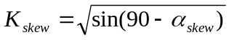 (3)

where the angle of skew is defined as the angle between the centreline of a pier, and a line normal to the roadway centreline.
Table 5: Coefficients for Evaluating K_{3D}
Equation | A | B | K_{3D}
EQ1 | 0.25 | 1 | 1 + 0.25 / (N – 1)
EQ2 | 0.33 | 0 | 1 + 0.33 / (N)
EQ3 | 0.33 | 1 | 1 + 0.33 / (N – 1)
EQ4 | 0.09 | 1 | 1 + 0.09 / (N – 1)
EQ5 | 0.05 | 0 | 1 + 0.05 / (N)
EQ6 | 0.20 | 1 | 1 + 0.20 / (N – 1)
EQ7 | 0.10 | 0 | 1 + 0.10 / (N)

Also note that I_{shape} in Table 3 is a Boolean indicator. When I_{shape} = 0, then the K_{shape} factor, which is a modifier that converts cases for short periods to an equivalent spectral amplitude at T = 1.0 second, does not apply. On the other hand, When I_{shape} = 1, then the K_{shape} factor applies. The K_{shape} factor also only applies for modifying the median fragility curve parameter for damage state 2:

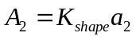 (4)

where a₂ = the spectral acceleration (T = 1.0 sec) given in Table 6, and

K_{shape} = 2.5 Sa(1.0 sec) / Sa(0.3 sec) (5)

The modified median fragility curve parameter is given for damage states 3, 4, and 5 by:

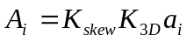 (6)

where a_{i} = the median spectral acceleration (T = 1.0 sec) for the ith damage state given in Table 6.

Table 6: Damage Algorithms for Bridges
Class | Sa [1.0 sec in g’s] for Damage Functions  due to Ground Shaking
Class | Slight (a₂) | Moderate (a₃) | Extensive (a₄) | Complete (a₅)
HWB1 | 0.40 | 0.50 | 0.70 | 0.90
HWB2 | 0.60 | 0.90 | 1.10 | 1.70
HWB3 | 0.80 | 1.00 | 1.20 | 1.70
HWB4 | 0.80 | 1.00 | 1.20 | 1.70
HWB5 | 0.25 | 0.35 | 0.45 | 0.70
HWB6 | 0.30 | 0.50 | 0.60 | 0.90
HWB7 | 0.50 | 0.80 | 1.10 | 1.70
HWB8 | 0.35 | 0.45 | 0.55 | 0.80
HWB9 | 0.60 | 0.90 | 1.30 | 1.60
HWB10 | 0.60 | 0.90 | 1.10 | 1.50
HWB11 | 0.90 | 0.90 | 1.10 | 1.50
HWB12 | 0.25 | 0.35 | 0.45 | 0.70
HWB13 | 0.30 | 0.50 | 0.60 | 0.90
HWB14 | 0.50 | 0.80 | 1.10 | 1.70
HWB15 | 0.75 | 0.75 | 0.75 | 1.10
HWB16 | 0.90 | 0.90 | 1.10 | 1.50
HWB17 | 0.25 | 0.35 | 0.45 | 0.70
HWB18 | 0.30 | 0.50 | 0.60 | 0.90
HWB19 | 0.50 | 0.80 | 1.10 | 1.70
HWB20 | 0.35 | 0.45 | 0.55 | 0.80
HWB21 | 0.60 | 0.90 | 1.30 | 1.60
HWB22 | 0.60 | 0.90 | 1.10 | 1.50
HWB23 | 0.90 | 0.90 | 1.10 | 1.50
HWB24 | 0.25 | 0.35 | 0.45 | 0.70
HWB25 | 0.30 | 0.50 | 0.60 | 0.90
HWB26 | 0.75 | 0.75 | 0.75 | 1.10
HWB27 | 0.75 | 0.75 | 0.75 | 1.10
HWB28 | 0.80 | 1.00 | 1.20 | 1.70

Example (After HAZUS, 2003)

Consider a three-span simply supported prestressed concrete bridge seated on neoprene bearings located in the Memphis area. Table 7 lists the data for this bridge obtained from NBI. For the scenario earthquake, assume that the ground motion is as follows:

Sa(0.3 sec) = 2.1g,
Sa(1.0 sec) = 0.43g

The median spectral acceleration ordinates for different damage states are determined as follows:

The bridge is classified:
Table 7: Bridge data necessary for the analysis
NBI field | Data | Remarks
27 | 1968 | Year built
34 | 32 | Angle of skew
43 | 501 | Prestressed concrete, simple span
45 | 3 | Number of spans
48 | 23 | Maximum span length (m)
49 | 56 | Total bridge length (m)

The HAZUS default class for this bridge based on the information above is HWB17
Next, the parameters needed in evaluating the median spectral accelerations are computed:

K_{shape} = 2.5 x Sa(1.0 sec) / Sa(0.3 sec) = 0.51

K_{3D} = 1 + A / (N – B) = 1 + 0.25 / (3-1) = 1.125

From Table 3, I_{shape} is 0 for HWB17, so “long periods” govern and K_{shape} becomes 1 (i.e. disregard the above calculation for K_{shape}). Therefore:
A₂ = 1 * 0.25g = 0.25g
A₃ = 0.92 * 1.125 * 0.35g = 0.36g
A₄ = 0.92 * 1.125 * 0.45g = 0.47g
A₅ = 0.92 * 1.125 * 0.70g = 0.72g
With the new medians, the shaking-related discrete damage state probabilities are (using Equation 1 and with β_{c} equal to 0.6):
P[No damage] = 1 – 0.82 = 0.18
P[Slight damage] = 0.82 – 0.62 = 0.20
P[Moderate damage] = 0.62 – 0.44 = 0.18
P[Extensive damage] = 0.44 – 0.20 = 0.24
P[Complete damage] = 0.20

These results can be seen graphically in Figure 1.

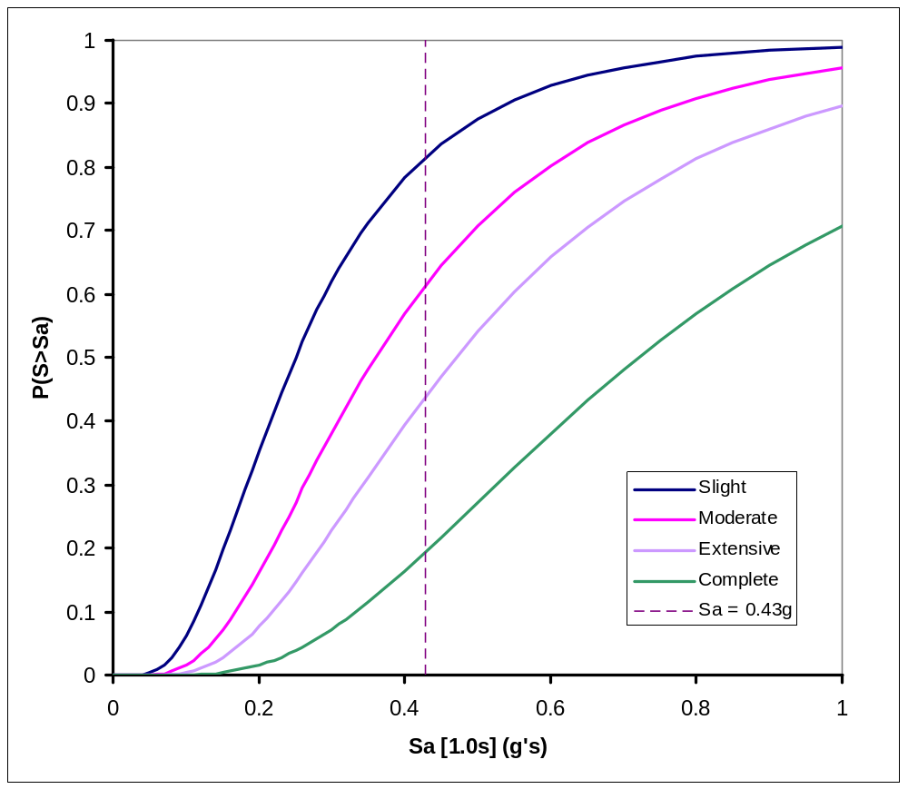
Figure 1: Highway Bridge Fragility Curves

Restoration Curves
The restoration curves used by HAZUS were developed based on a best fit to ATC-13 data consistent with damage states defined previously (first four classes in ATC-13). Figure 2 represents restoration curves for highway bridges. The curves shown are normal curves characterized by a mean and a standard deviation. The parameters defining these restoration curves are given in Table 8. Table 9 gives approximate discrete functions for the restoration curves developed.

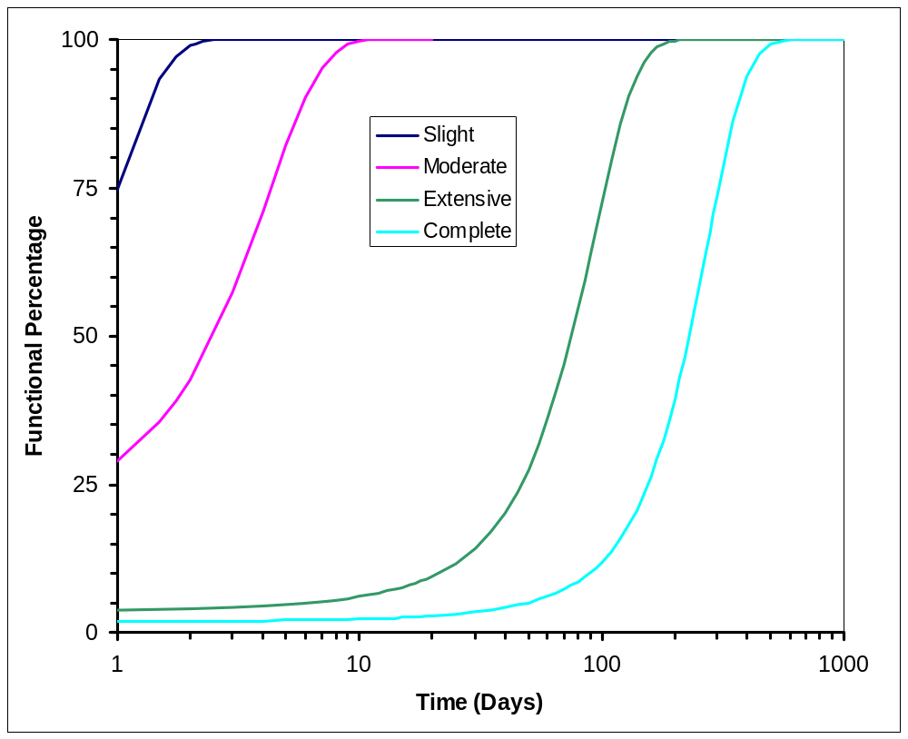
Figure 2: Restoration Curves for Highway Bridges (after ATC-13, 1985)

Table 8: Continuous Restoration Functions for Highway Bridges (after ATC-13, 1985)
Damage State | Mean  (days) | σ  (days)
Slight/Minor | 0.6 | 0.6
Moderate | 2.5 | 2.7
Extensive | 75.0 | 42.0
Complete | 230.0 | 110.0

Table 9: Discrete Restoration Functions for Highway Bridges
Restoration Period | Functional Percentage
Restoration Period | Slight | Moderate | Extensive | Complete
1 day | 70 | 30 | 2 | 0
3 days | 100 | 60 | 5 | 2
7 days | 100 | 95 | 6 | 2
30 days | 100 | 100 | 15 | 4
90 days | 100 | 100 | 65 | 10

GA’s Approach
It is currently proposed that GA adopt the HAZUS methodology for assessing bridge behaviour under seismic ground shaking. There are a number of issues that need to be addressed in doing this:
Applicability of US models
The issue here is whether the bridge fragility models used in HAZUS are applicable to Australian bridges. Some of the 28 bridge classifications used in HAZUS will be more appropriate to Australian highway bridges than others, so I would suggest ignoring the classes shaded grey in Table 4. This would exclude seismically designed bridges (except in the case of a major bridge), and also conventionally designed Californian bridges. The assumption made here is that Australian bridges are not designed to resist seismicity to the same level of rigour as those in the US. It may be that the seismically designed major bridge (HWB2) is not realistic in the Australian context either.
Permanent Ground Deformation (PGD)
It is proposed to concentrate on the damaging effects of ground shaking only at this stage, and not to consider ground failure and subsequent damage. The HAZUS methodology allows for PGD causing Extensive or Complete damage, and doesn’t consider Slight or Moderate damage.
Bridge Data Required
US researchers have the luxury of the National Bridge Inventory (NBI), a 116 field, up-to-date (every bridge is inspected every 2 years) nationwide database. This database provides all the necessary information for a HAZUS analysis incorporating the bridge structures. As far as I know no such database exists for Australia and we will need to get data on a study-by-study basis from road authorities in the relevant location. Data required to classify Australian bridges will include:
- location (lat & long)
- year built
- structure material type (see Table 1)
- structure type (see Table 2)
- bridge skew angle
- number of spans
- maximum span length
- span continuity (continuous, discontinuous, or simply supported)
- pier type (multiple column bents, single column bents, pier walls)
The HAZUS manual also claims you need to know abutment type and bearing type but I can’t see how that information would influence any of the classifications in Table 4.
EQRM
This type of analysis could be simply carried out in EQRM. For the initial catastrophic disaster work it may be more efficient to perform spreadsheet based analyses rather than get involved in MATLAB coding. In any case, some minor modification to EQRM would be necessary in order to obtain spectral accelerations at periods of 0.3 sec and 1.0 sec at bridge locations.
Conclusions
This paper summarises the HAZUS-MH methodology for assessing damage to highway bridge structures exposed to ground shaking, and proposes to use the same methodology at Geoscience Australia. Fragility curves are used in calculating probabilities that a bridge will be in a certain damage state following an earthquake. Restoration curves relating to each damage state can be used to estimate repair times.
A number of issues have been raised that will need to be addressed before the method can be applied as part of the Catastrophic Disasters pilot in Western Australia.

References
Applied Technology Council (1985). “Earthquake Damage Evaluation Data for California,” ATC-13, Redwood City, CA, USA.
Federal Highway Administration. “National Bridge Inventory.”
FEMA (2003). “HAZUS-MH Technical Manual,” Washington DC, USA.
Mander, J. B. and Basöz, N. (1999). “Seismic fragility curve theory for highway bridges,” Optimizing Post-Earthquake Lifeline System Reliability - Proceedings of the 5th US Conference on Lifeline Earthquake Engineering, ASCE, USA. pp.31-40.

